# RAP-07-01-List Report and Object Page-Enhance UI Annotations.docx

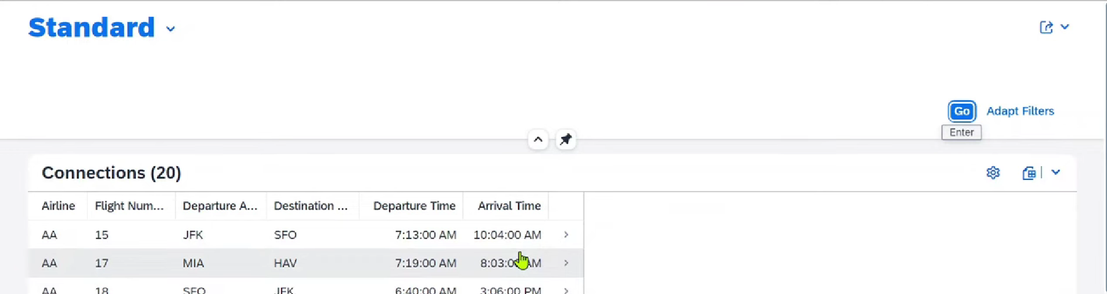

## Get the selection list- in ABAP selection screen: through adopt filters.

* Click on Adopt filters
* 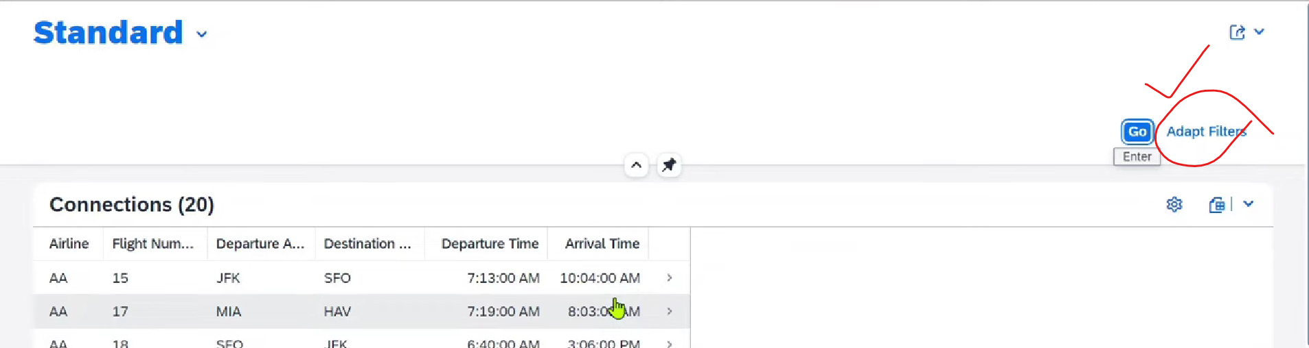
* 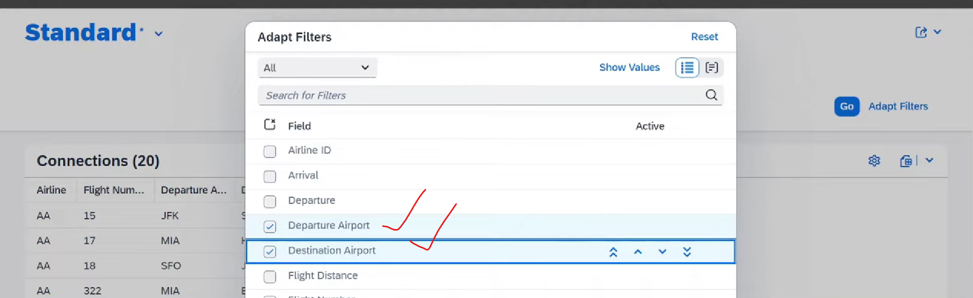
* 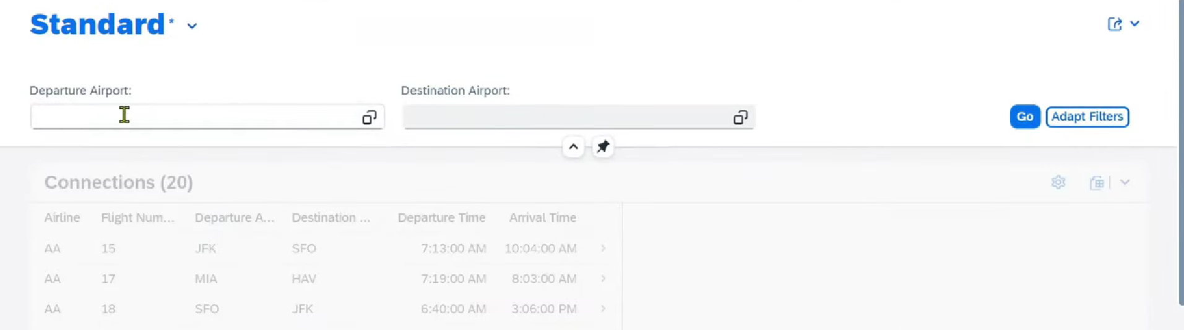
* 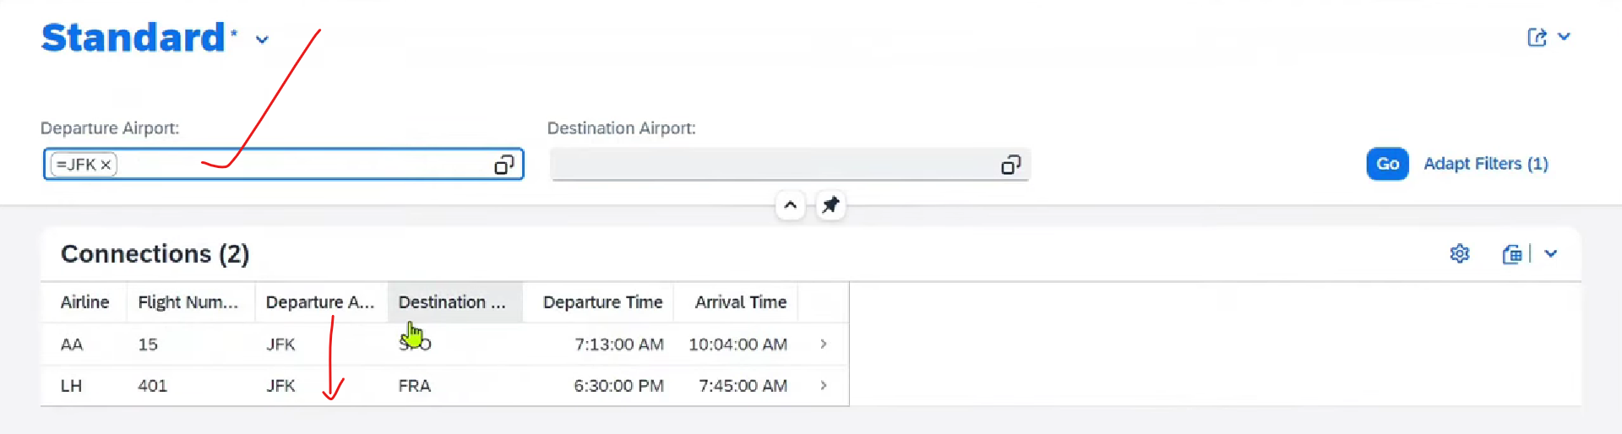
* 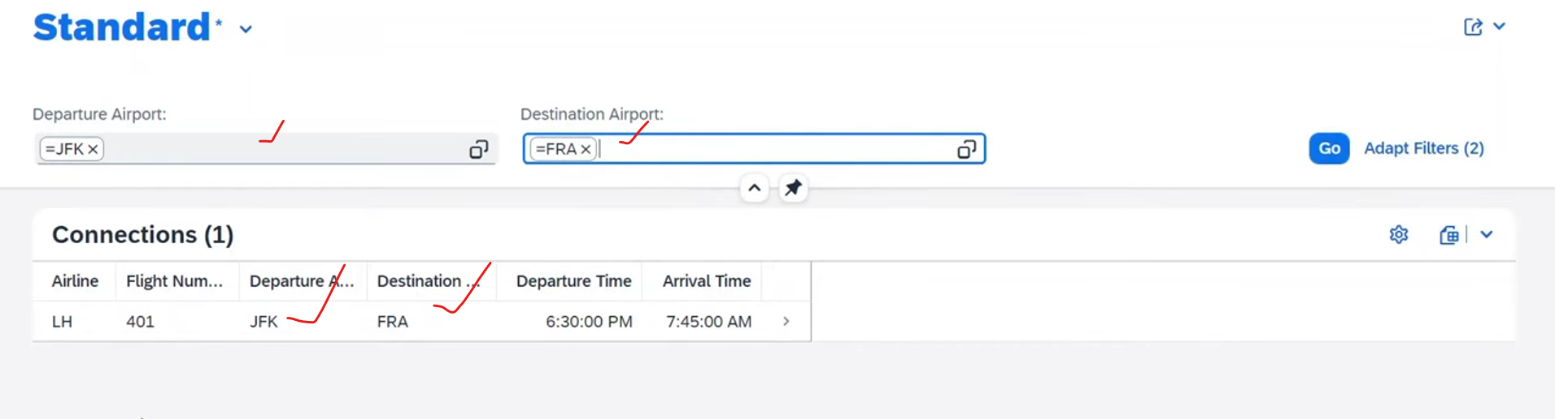

## @UI.selectionField- default filters

Default filters- When I Load the applications:

* @UI.selectionField:[{position:10}] on top of the fields.

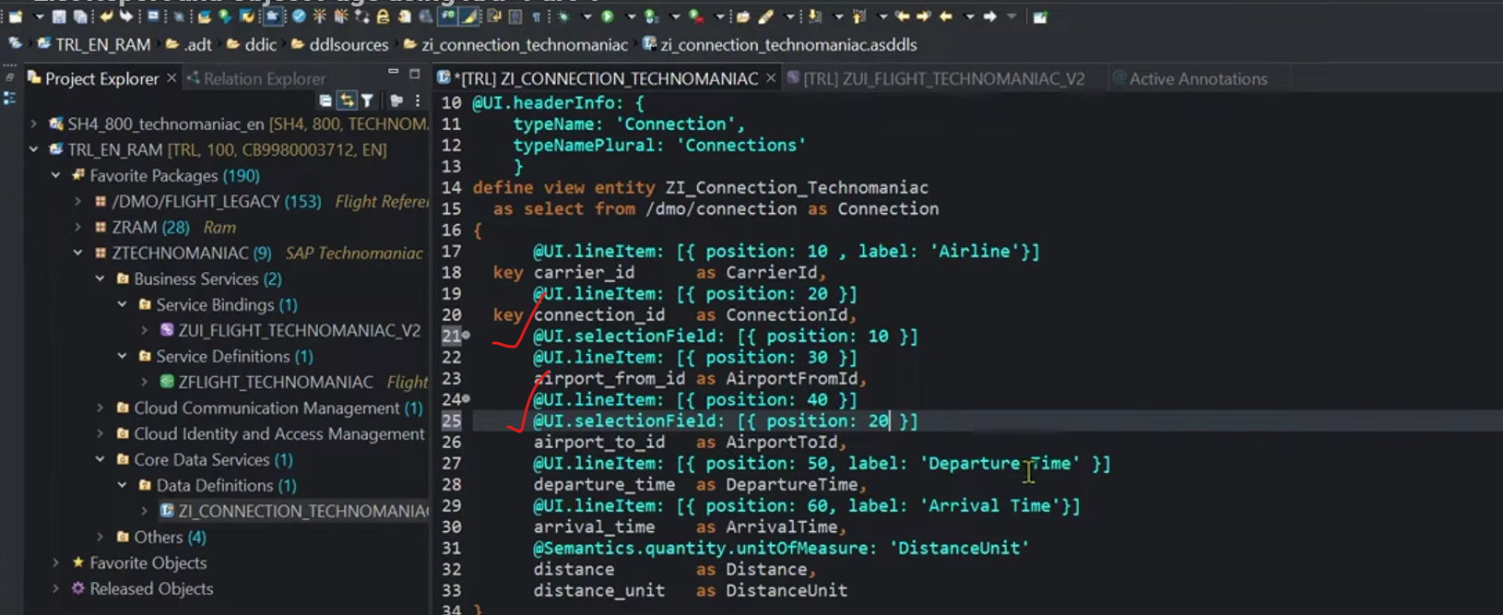

* Activate
* Output- selection screen by default
* 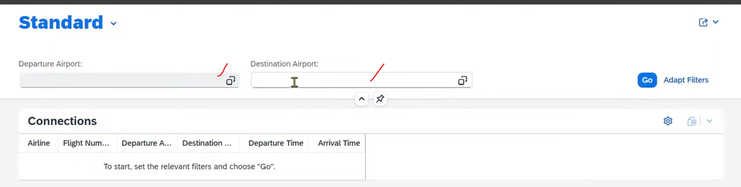
* 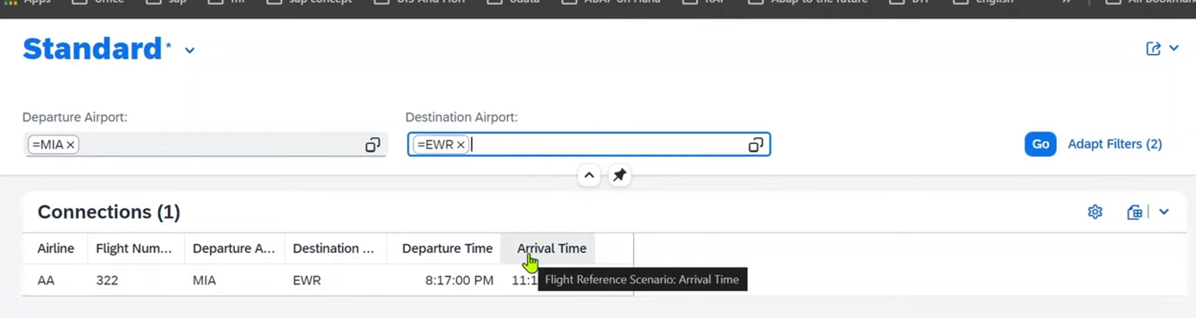

## Differences between list report vs object page

List report- Display over view of the general line items.- Basic list

Object Page- Detail about the specific line items. – Interactive

## Object Page:

In UI annotations (especially SAP Fiori/ABAP RAP), a **@UI.facet** defines logical sections or tabs on a screen (like an Object Page) to organize related data, grouping fields, charts, or other elements into user-friendly containers, improving layout and navigation by separating information into distinct areas such as "General Info," "Contact Details," or "Order History". Facets control how data is presented and structured within the UI without changing the underlying data model.

Object page at line item level.

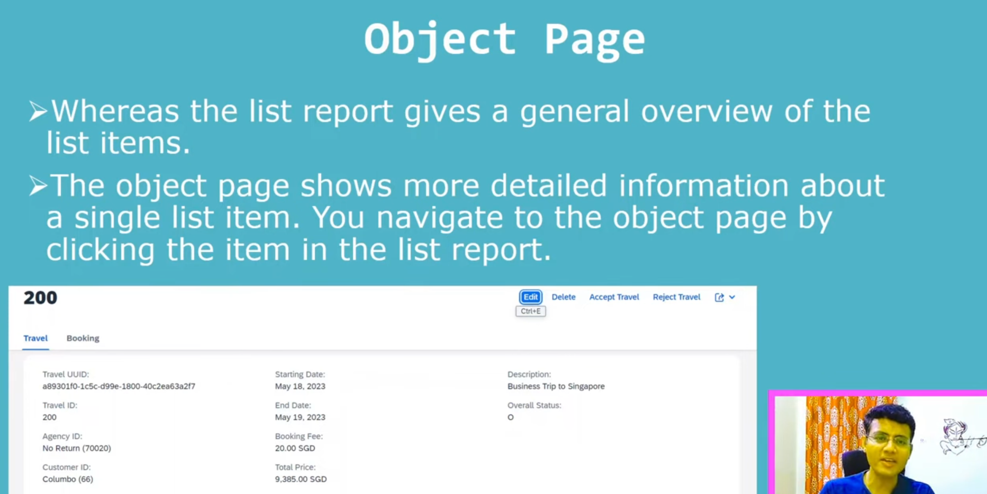

* In object page multiple data displayed in form of the facet.

### What is facet in UI?

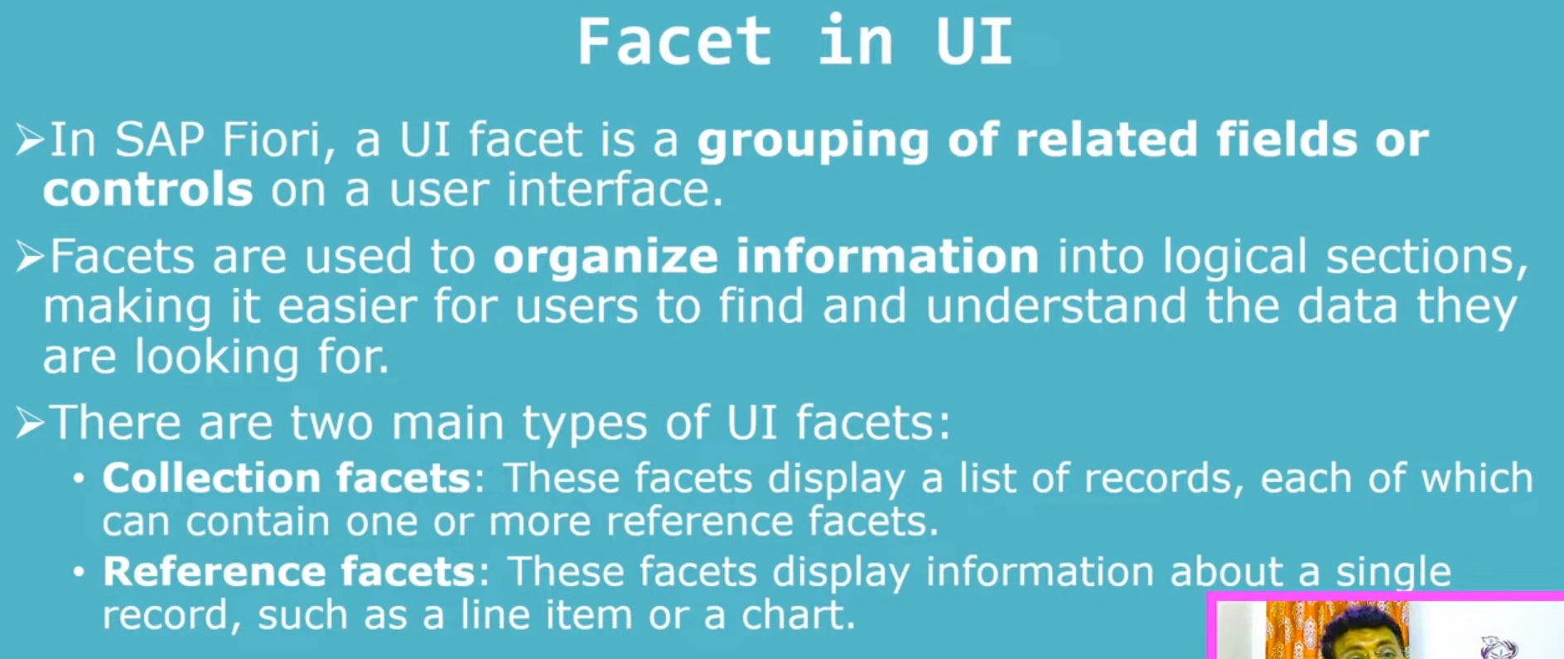

Facet- group the related information.

Facet – Organize the information, How it looks like?

Collection Facet:

* Is the list of the items.
* Inside the collection facet, we can use the reference facet like hierarchy facet and inside reference facet we can use the collection facet also.

Reference Facet- For specific item.

Example:

Display the collection of customers inside the collection facet, you have different different customers, for the particular customer again you have the reference facet, that will display the specific customer details and reference set have again customer facet- to display the list… etc .

* Means here data will display one inside another.

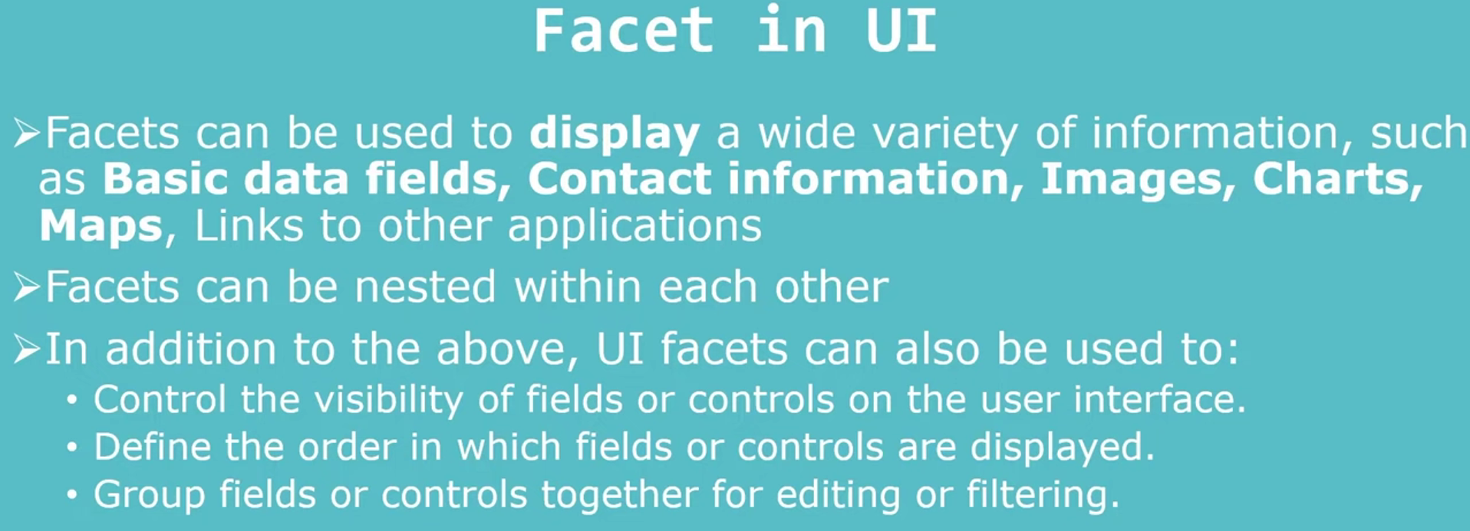

### IDENTIFICATION_REFERENCE Facet type

It is used to display the identical information.

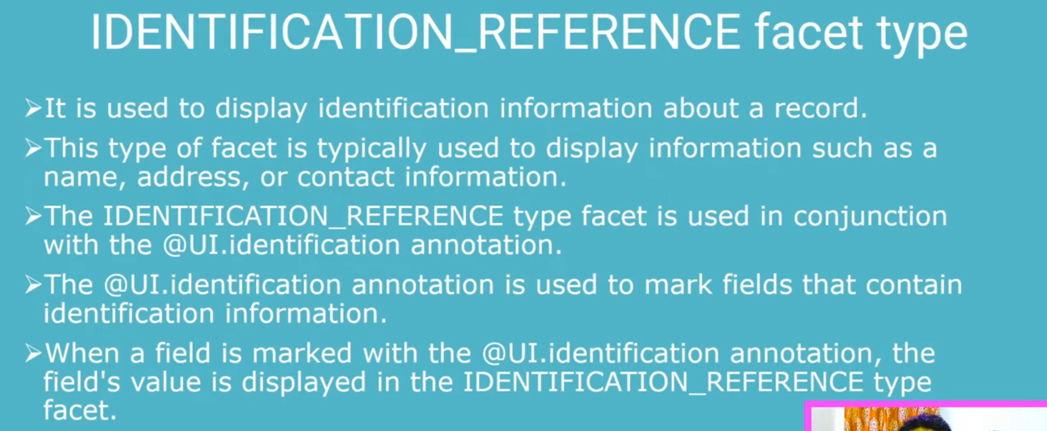

### @UI.facet:[{.. }]-Object page annotation :

* Provide in line item level
* @UI.facet- properties
  + Purpose: #STANDARD, #HEADER, #FILTER, #QUICK_CREATE, #QUICK_VIEW
    - #STANDARD: facet display in the ui main content area.
  + Type- #ADDRESS_REFERENCE/#BADGE_REFERENCE/#CHART_REFERENCE/#COLLECTION/CONTACT_REFERENCE/#IDENTIFICATION_REFERENCE
    - #IDENTIFICATION_REFERENCE- Used to group/connection the fields
  + Position: 10, suppose if you have the multiple facet, what is the position of the specific facet to display..
  + Label- provide the label for specific facet.

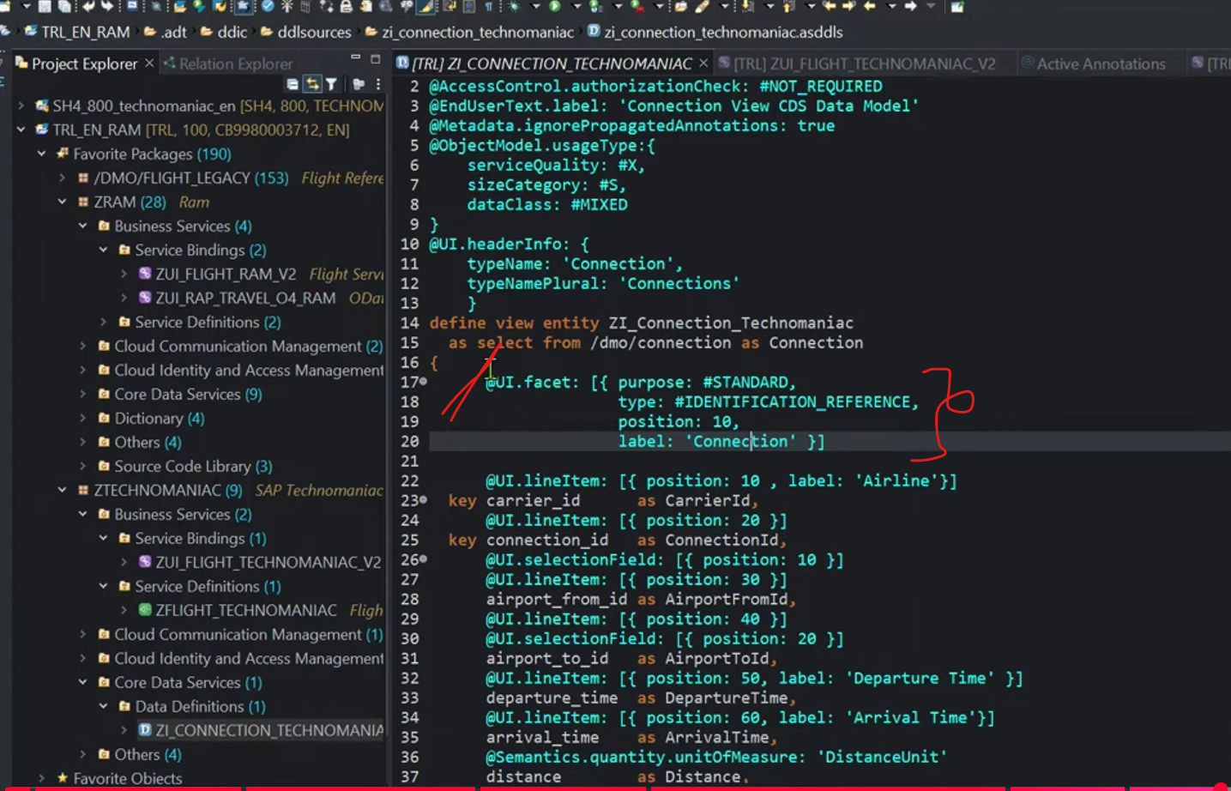

Save and activate

Output:

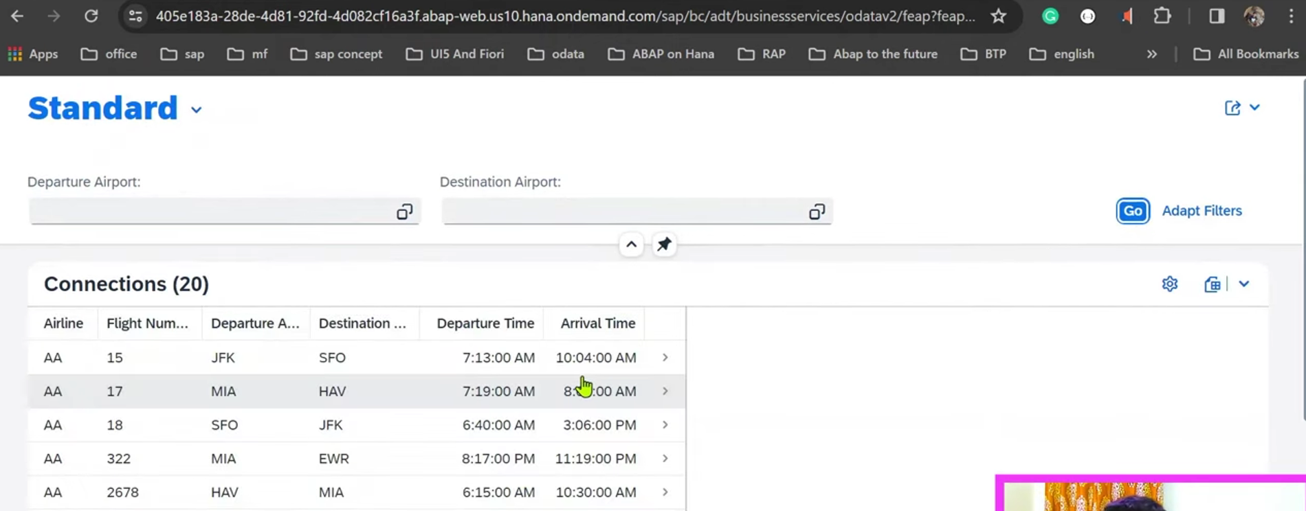

I want to display specific line item: 🡪 so click on the first line item.

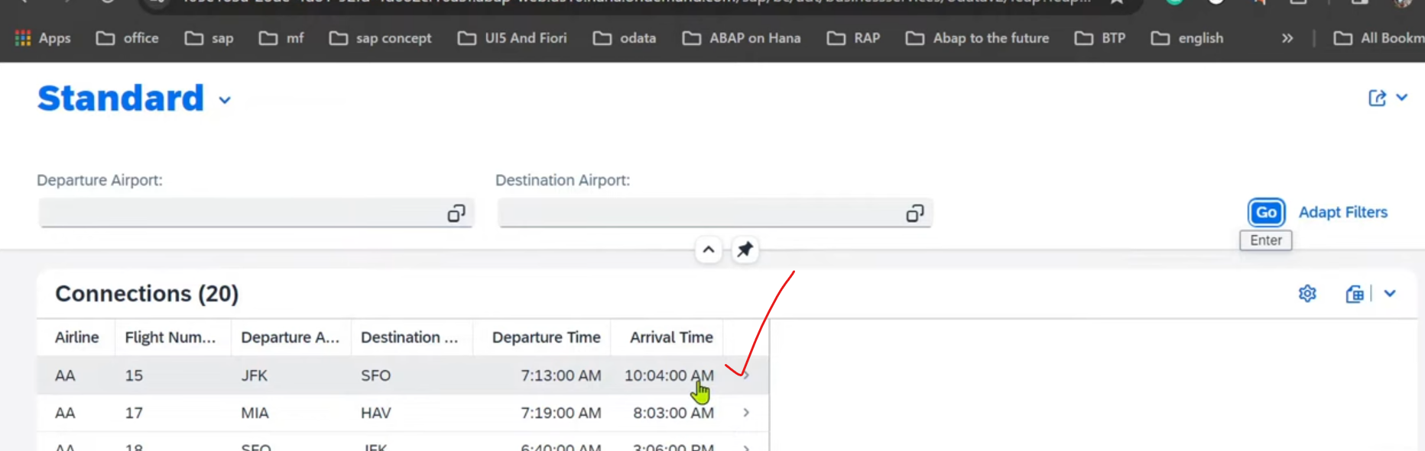

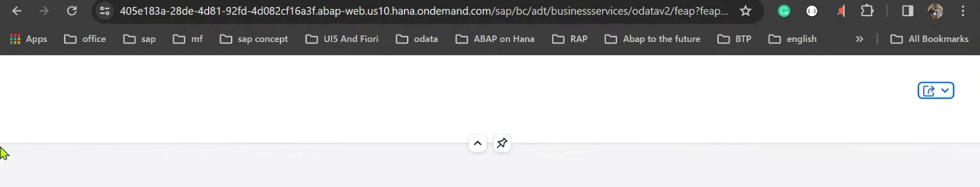

As of now there is no fields are mapped to this facet.

Provide the facet on field level also,

@ui.identification:[{..}].

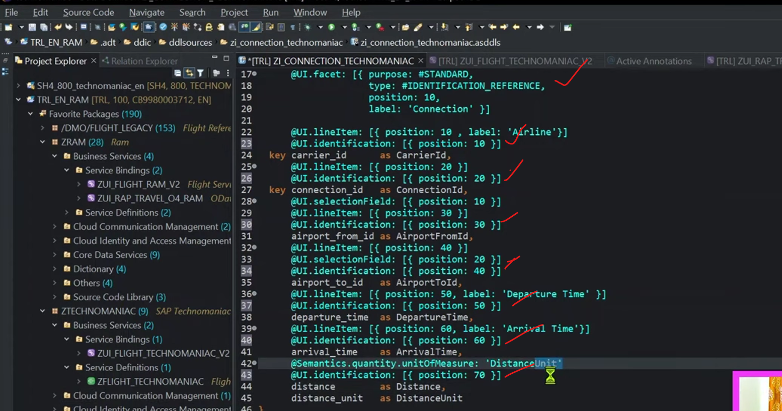

Save and activate.

Output:

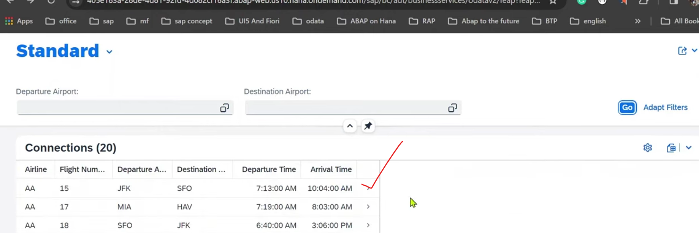

Click on first line item.

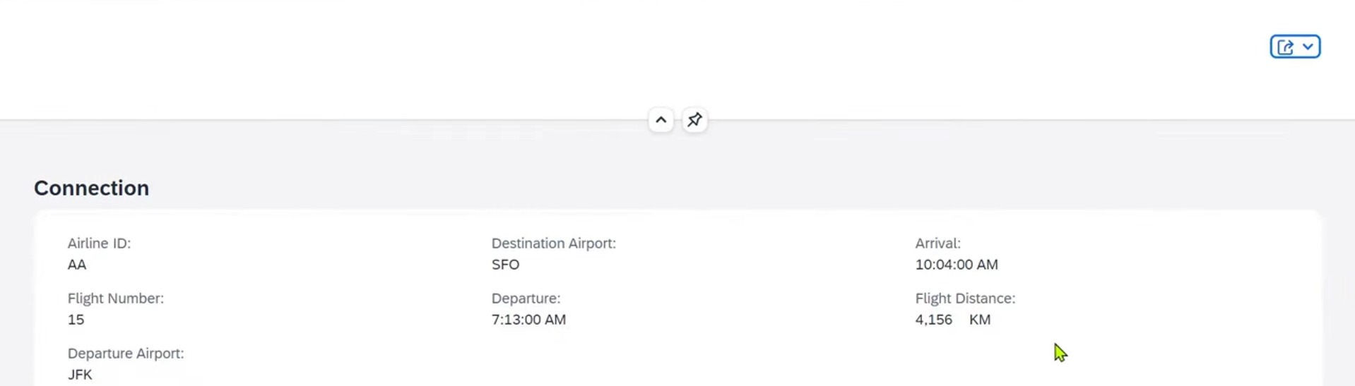

Display fields add it to one section as connection – called as facet/section.

Change the label name for section.

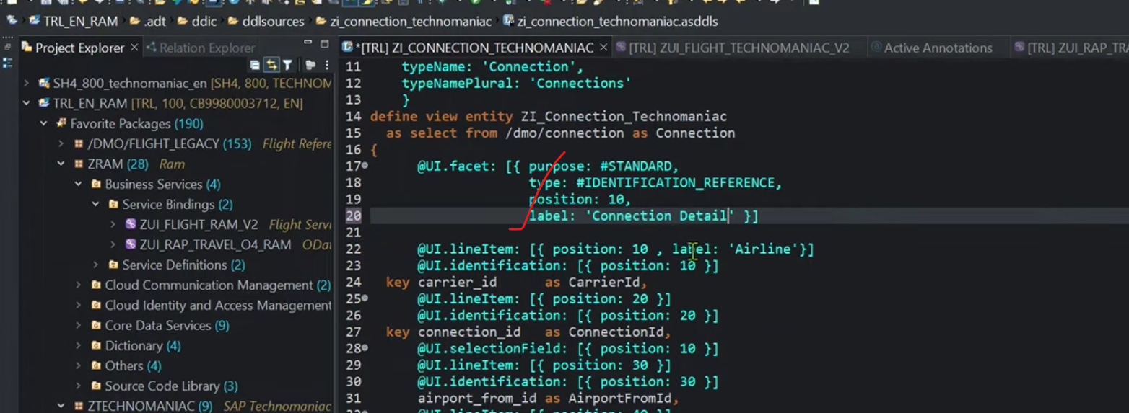

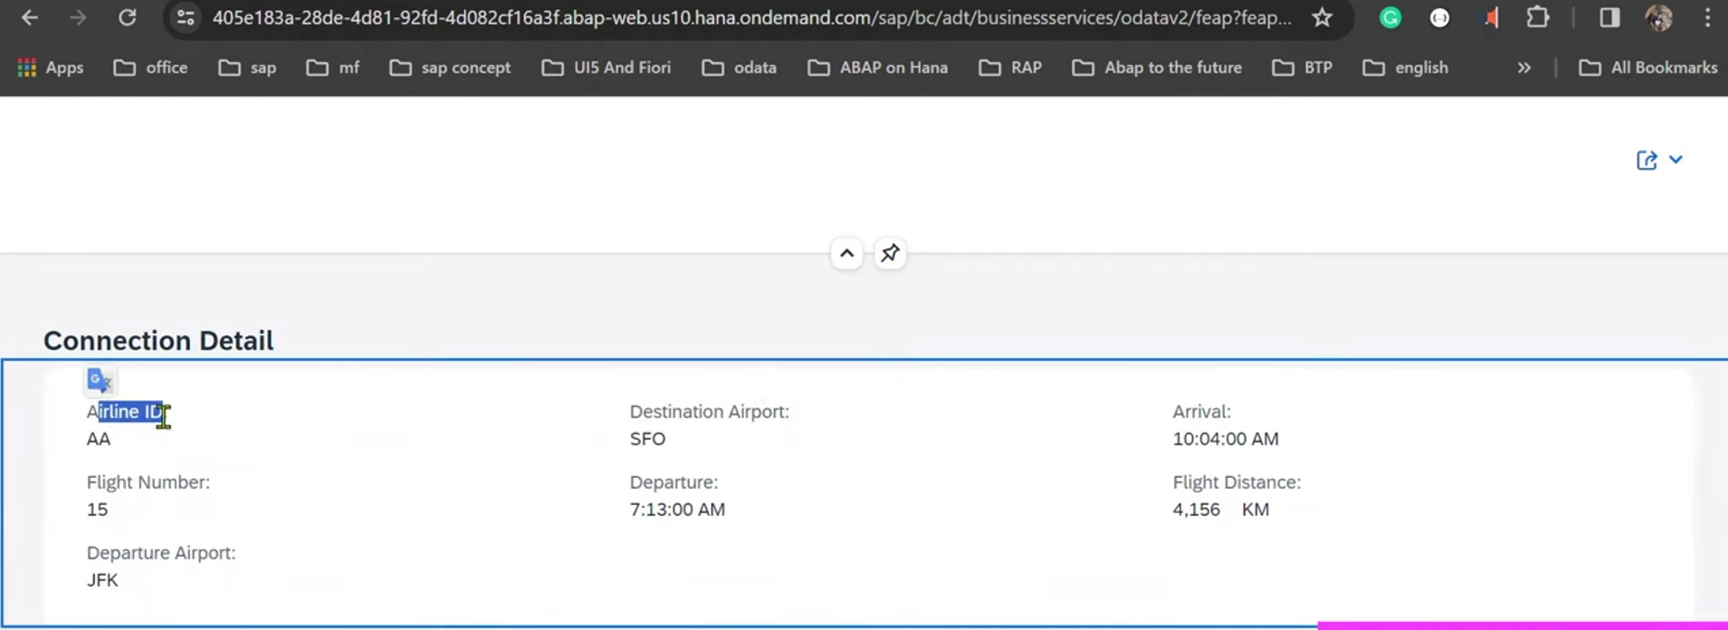

Object page also field level label name also changed.. using @UI.idenitification:[{label:’…’}].

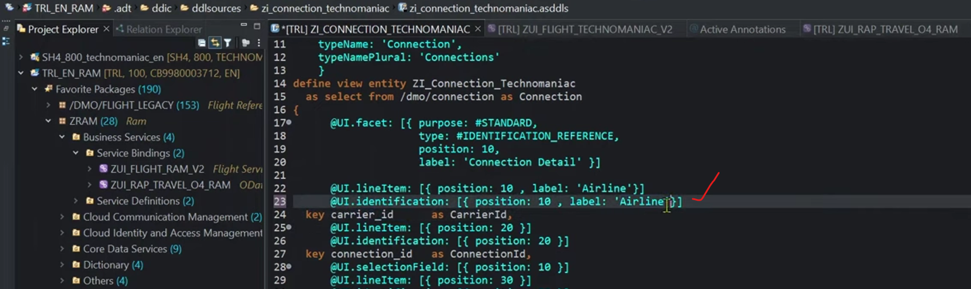

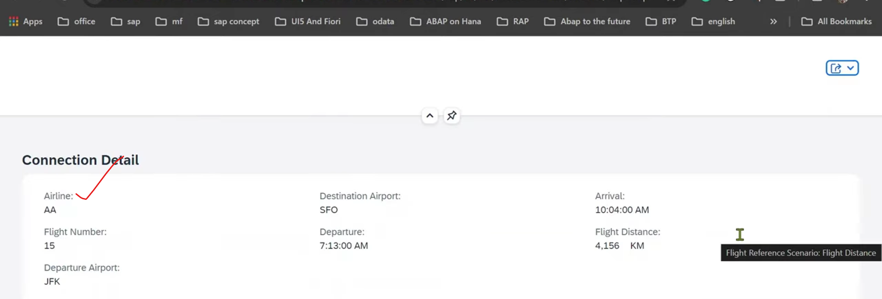

### Sort and Group BY:

1. Click on settings.

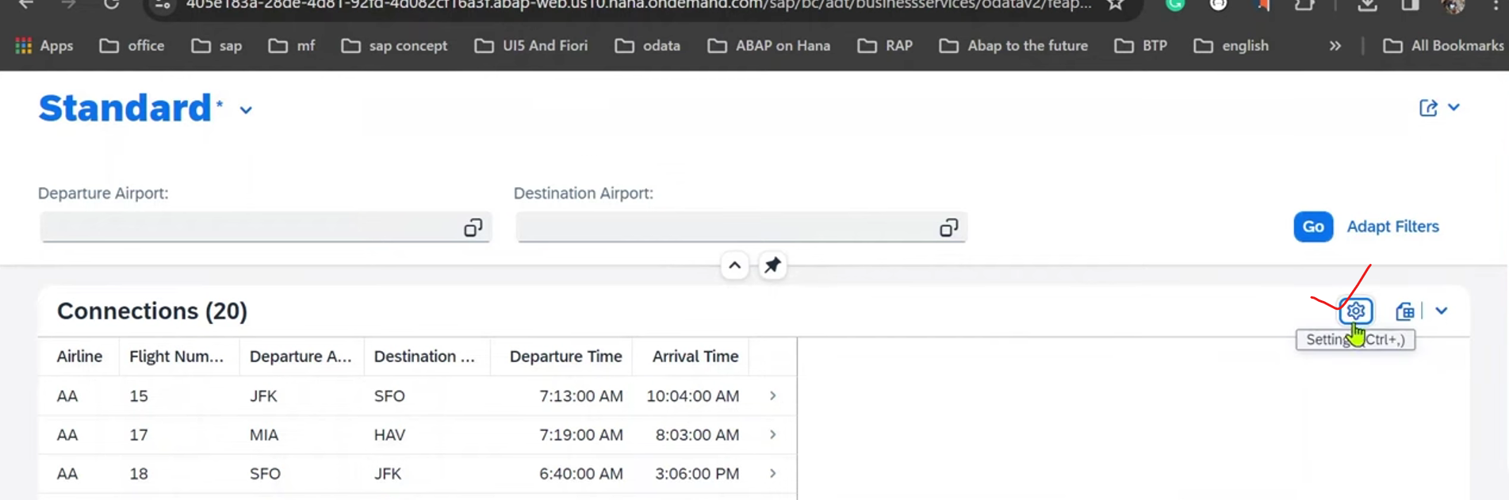

1. 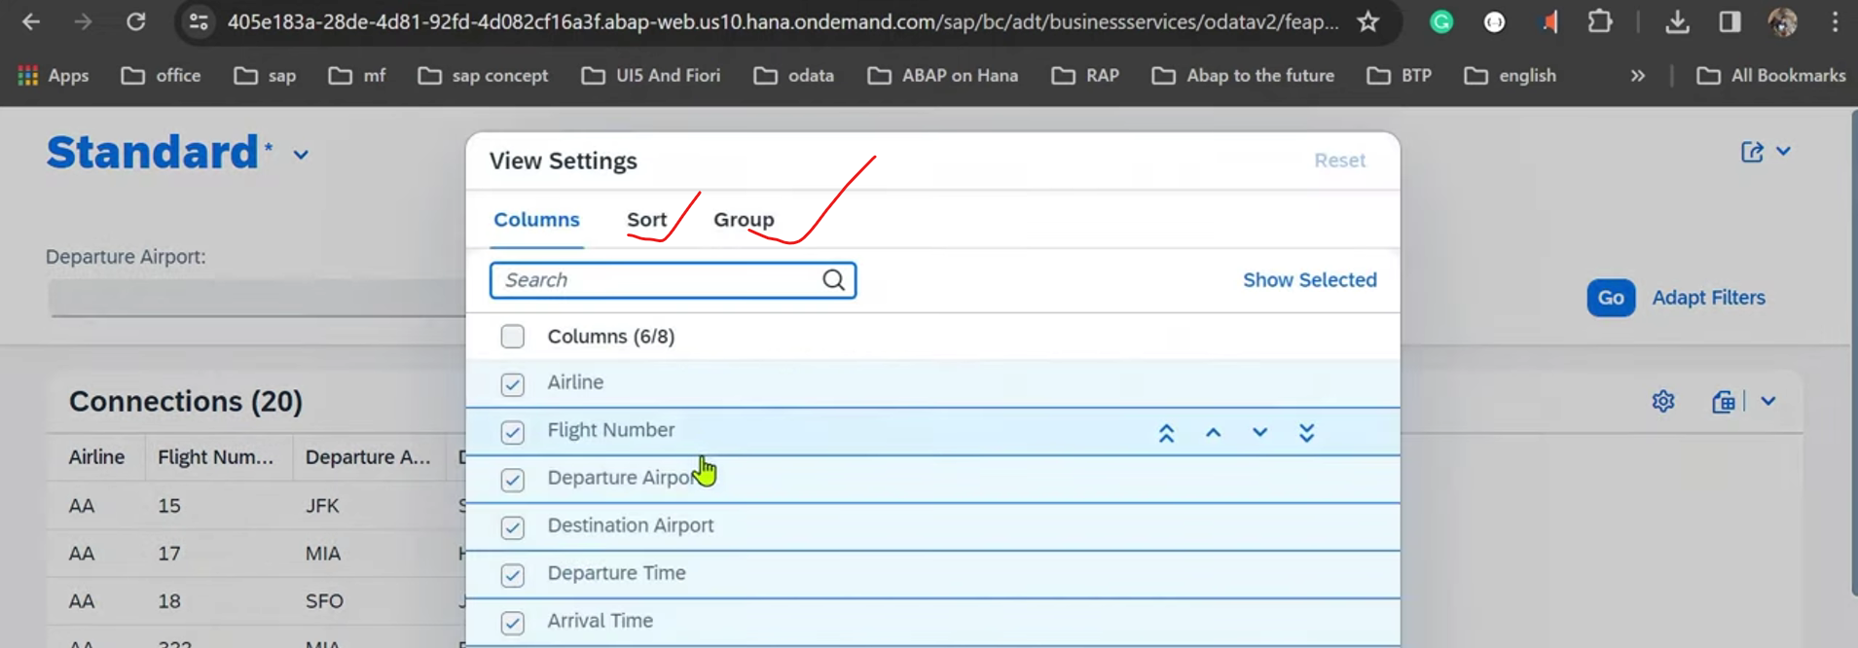
2. For sort🡪 click on sort tab.

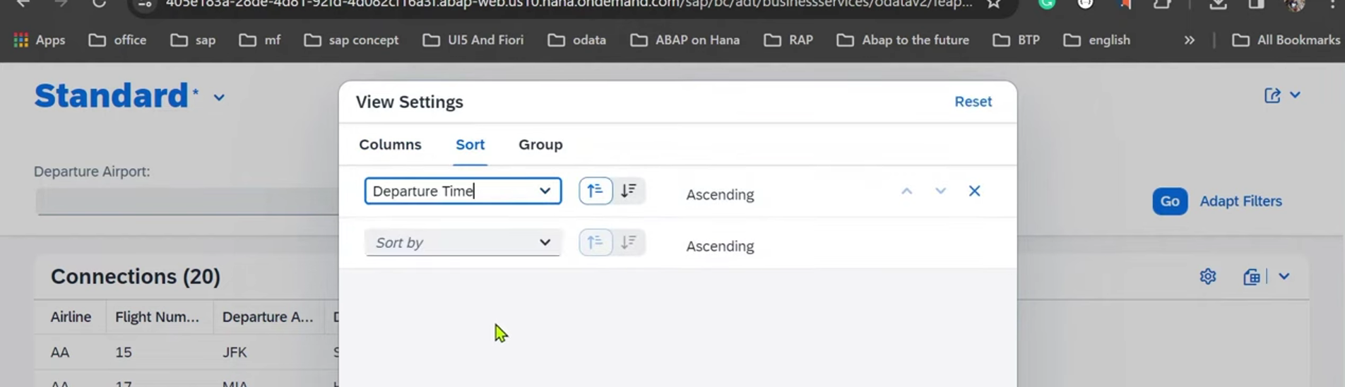

1. Automatically sort by ASCending order.
2. 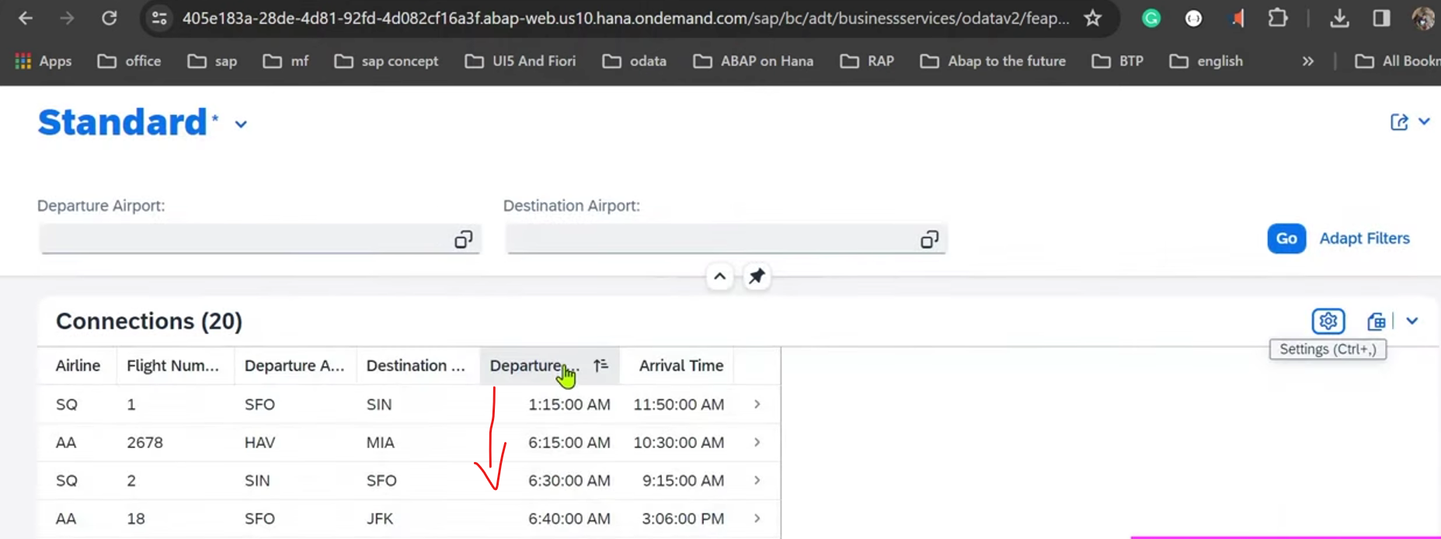
3. For group by

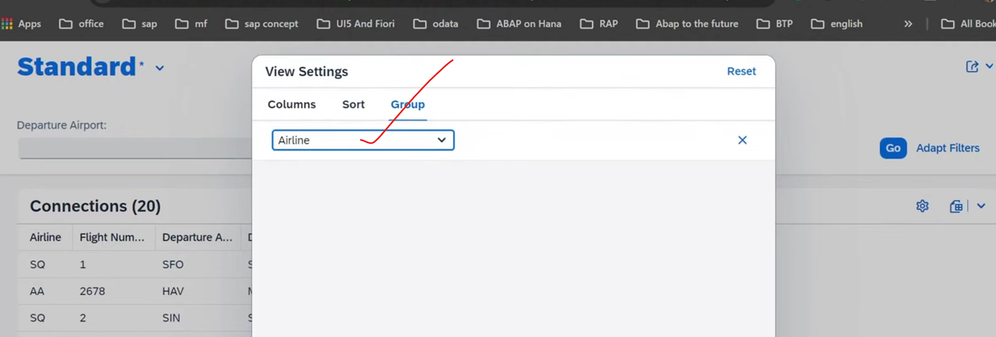

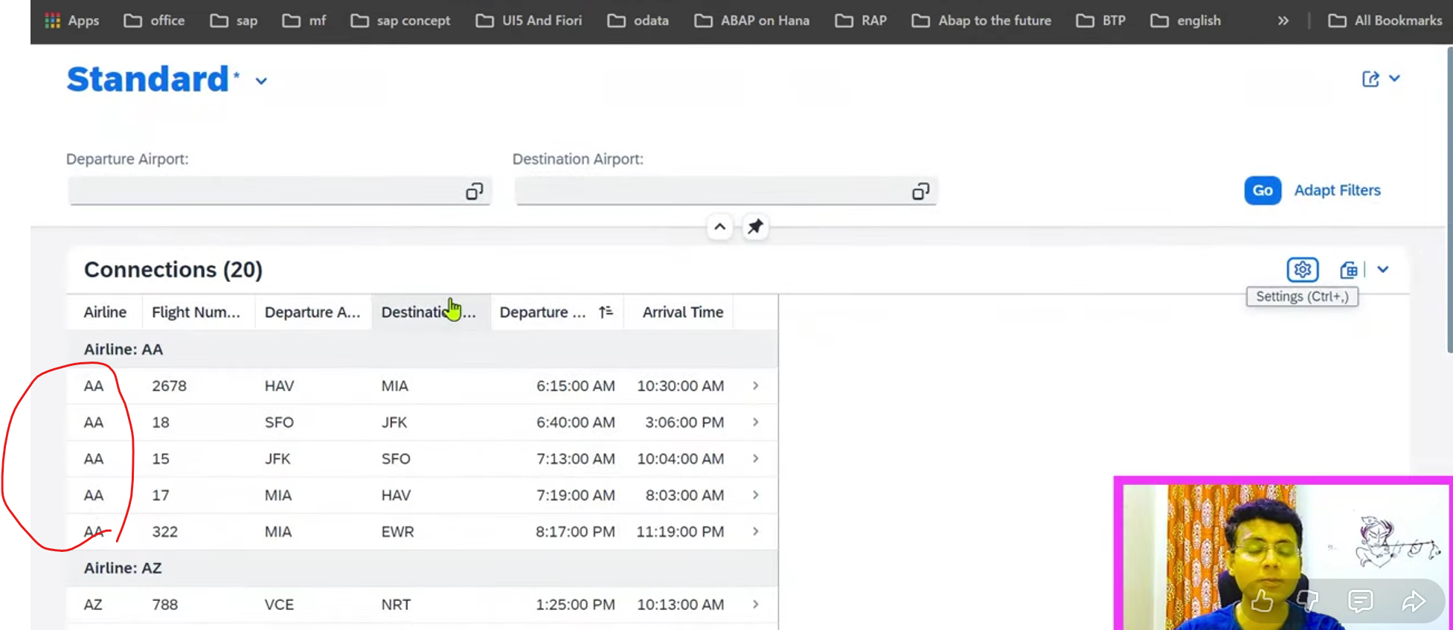

### SAVE- Variants:

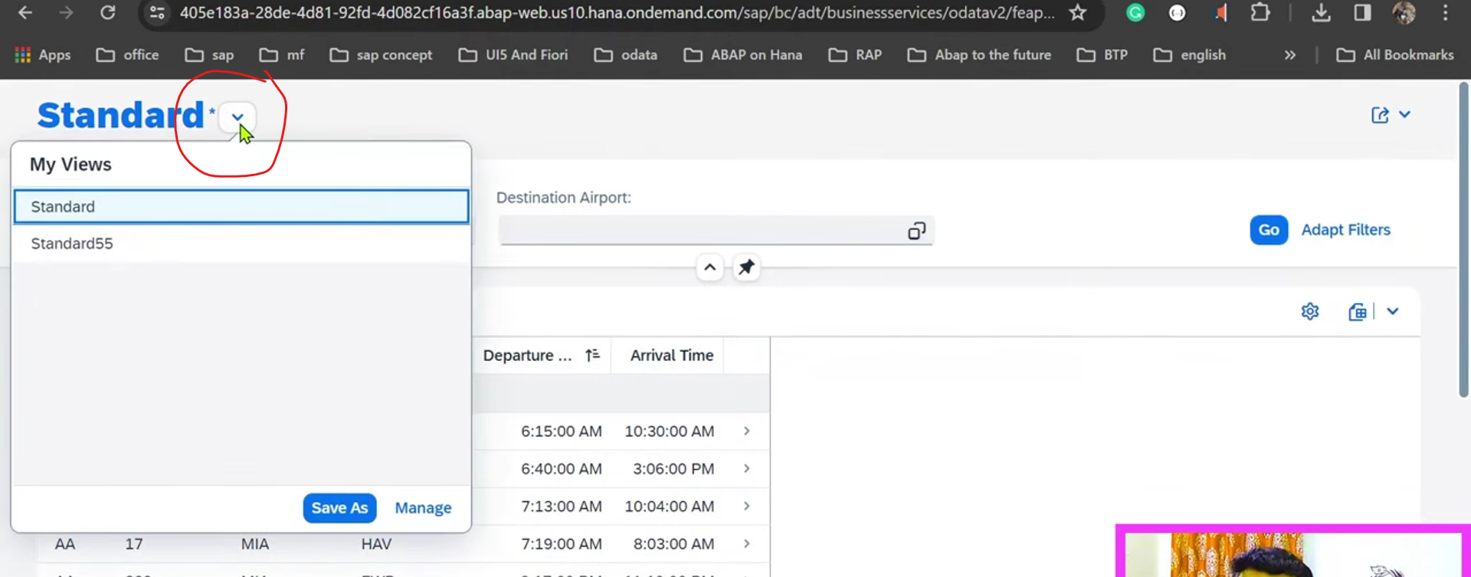

Click on save as and provide the your variant name.

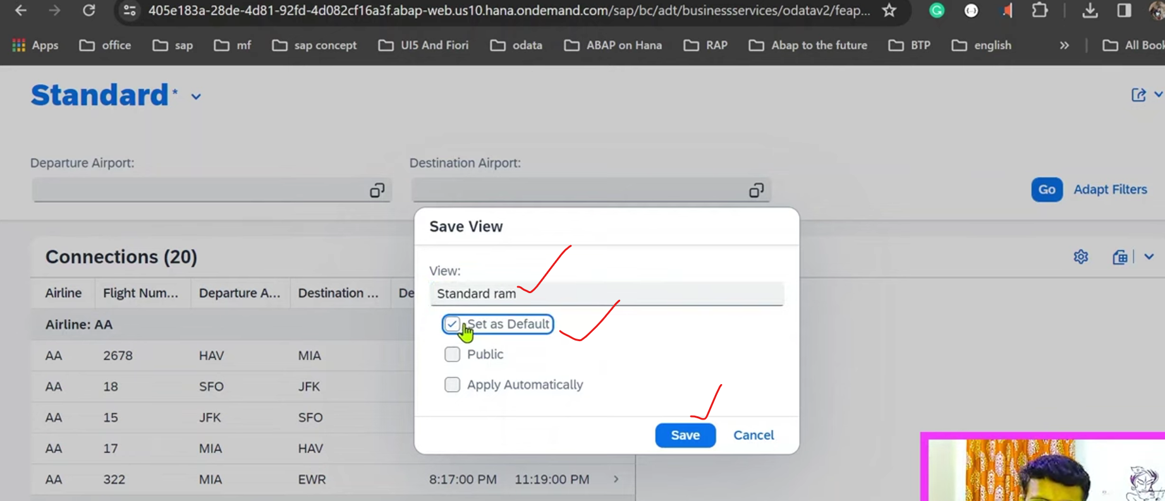

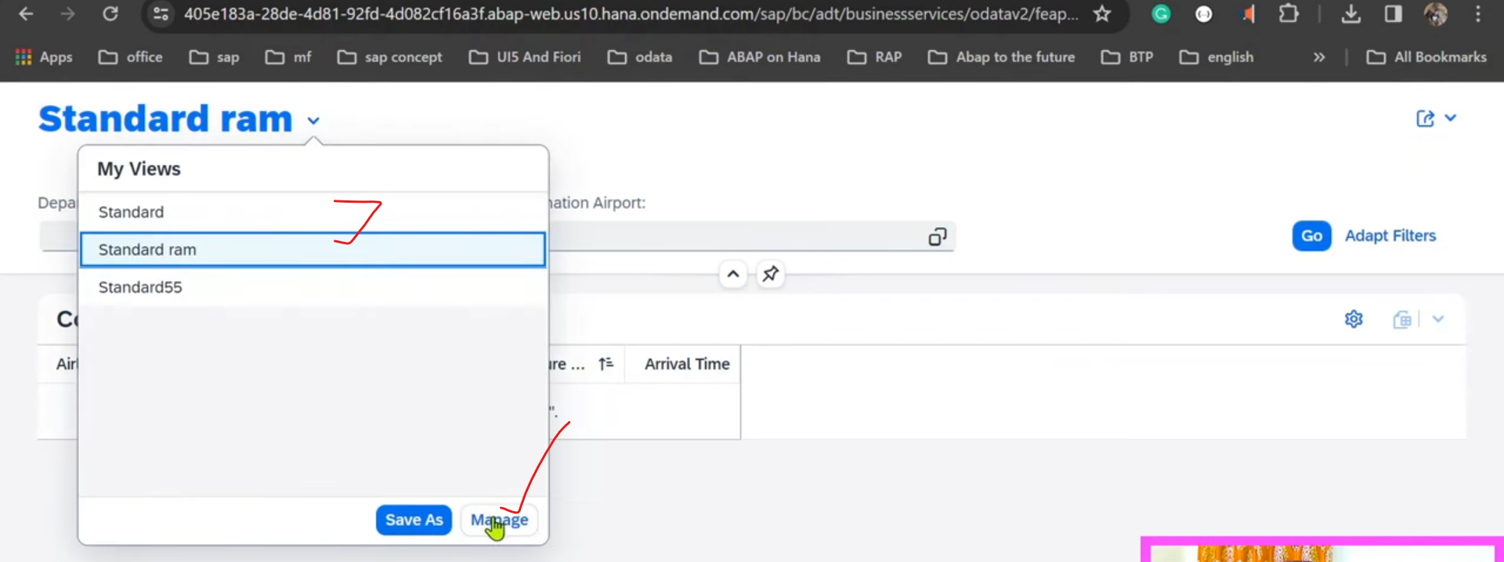

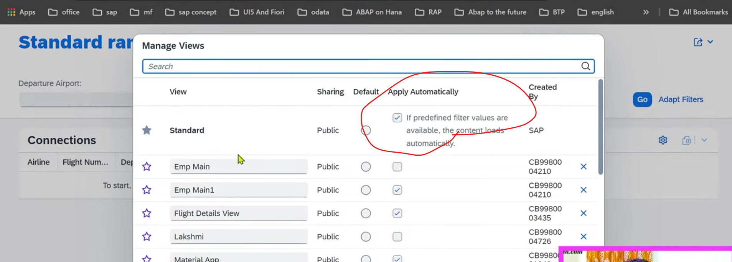

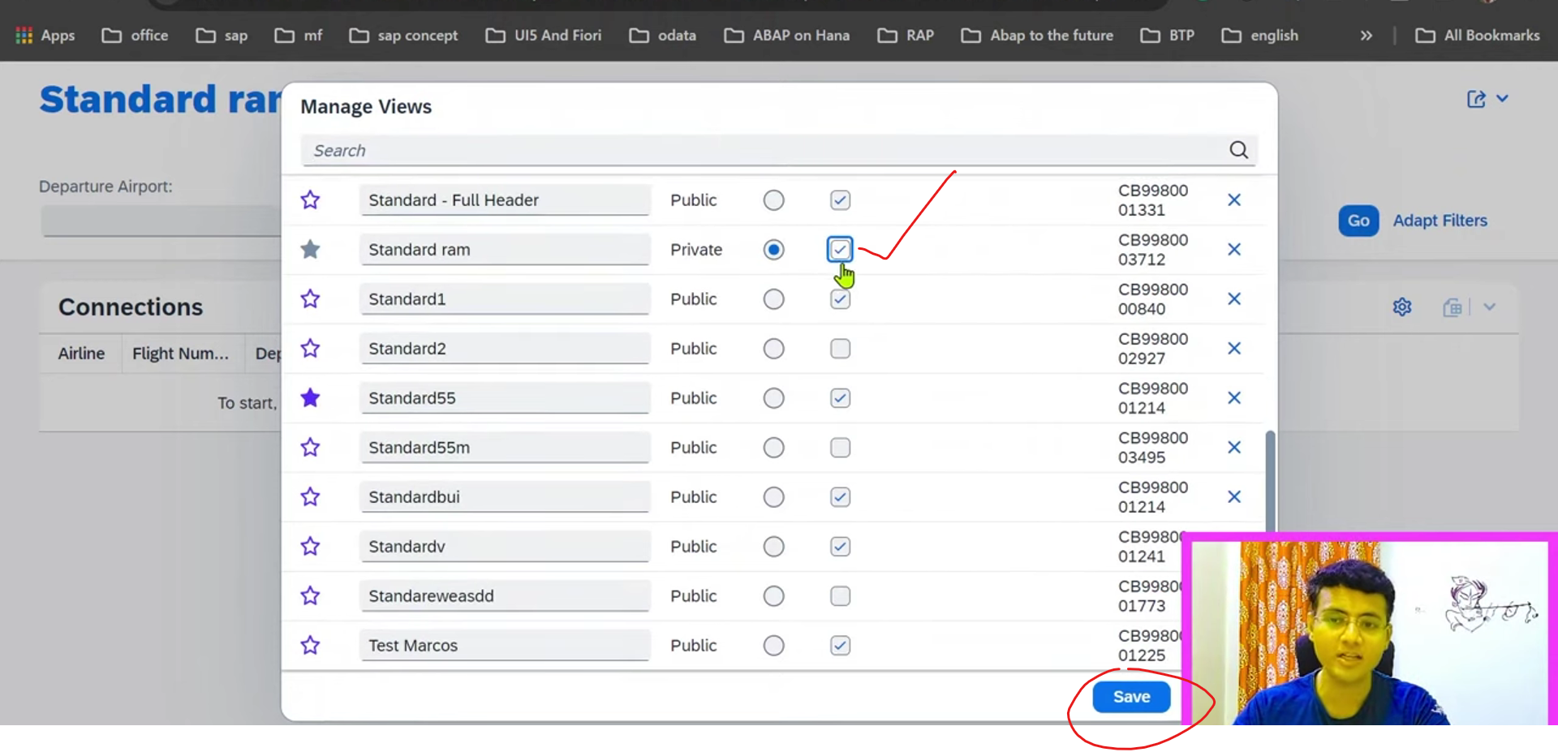

Next time whenever you open, automatically list report will open in saved format only.

Now refresh the screen at browser level.

